$540,000 owed to Bellevue project's workers

By IAN KIRKWOOD
Oct. 15, 2008, 11:47 a.m.
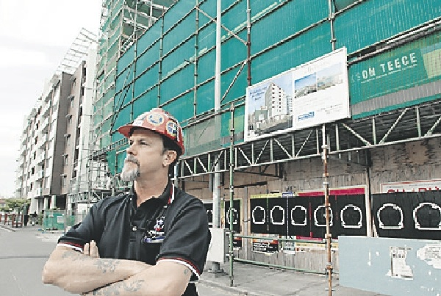
PROBLEM: Union official Russell Cunningham at the Newcastle West site yesterday.- Picture by Peter Stoop
THE already delayed Bellevue Hotel apartment block site has been shut down for a second time, with subcontractors owed an estimated $540,000 from six weeks' work.
The $7 million-plus Task Group building site was shut on Monday because of financial troubles engulfing its secured lender, Port Macquarie finance group Momentum Mortgages.
Momentum's advertisements say it has raised more than $53 million from more than 2000 investors.
Citing a downturn in the market, problem loans and a run on funds, the directors called in the administrators and a secured lender, Perpetual Nominees, had a receiver/manager appointed.
McGrathNicol froze investors' accounts on Monday and said the fate of at least $36 million remained "uncertain".
Construction, Forestry, Mining and Energy Union organiser Russell Cunningham said the smaller operators and individuals tended to be hardest hit when development projects ran into trouble.
Bellevue project manager Gerard Connoughton said work stopped in May and began again in August after Momentum paid debts estimated at $700,000.
Workers on the eight-storey site were now owed $540,000 for the past six weeks' work.
The shut-down caps a bad few weeks for one of the driving forces behind the Task Group, businessman Scott McKenzie, who was shot at outside his Carrington home on September 30.
Mr McKenzie said yesterday he was grazed on the right thigh by a bullet from a hooded gunman who he believed had been trying to steal his car.
He said the company behind the Bellevue job, Task Developments 2, was trading but he and his fellow directors were "winding back" the Task Group's operations.
Another company, Task Developments, which built the $25 million Dockside apartments at Carrington, went into voluntary administration on October 9 with SV Partners.
SV Partners spokesman Daniel Quinn said the company had three unsold units as assets

Tuesday November 20, 2012

FRANCES THOMPSON: City story told in stone
By FRANCES THOMPSON
Oct. 2, 2012, 9:51 p.m.
I'M standing on the corner of Hunter and Hannell streets.

The intersection is marked by the imposing, semi-circular Bank Corner building, but few people, if any, these days would notice or know.
What's left of Hannell Street is now called Bellevue Street and ends at the Beresford Garden, a tiny patch of flowers and shrubs by the Wickham railway station.
A collection of old photos has been placed on the garden fence, showing what looks like the old Hannell Street railway crossing, a group of workers and old Newcastle scenes.
Who put the pictures there? Why? Who takes care of the railway garden?
After a day of walking and cycling around old Newcastle, you start to see things differently.
Opposite the Bellevue Hotel apartment redevelopment, a two-storey, probably 19th century house with an iron-lace verandah, is squeezed at a crazy angle into the surrounding multi-storey buildings.
The house seems stranded, looking back on its past as the city has been realigned.
The grubby shopfronts of Newcastle West, such as the Australian Agricultural Company's 1935 Corona Building, have upper levels of intricate brickwork.
Rounded windows and chimney pots, remnants of the original buildings, defy renovation, as if to say: "I'm still here."
Some of these are old emporia.
The sweep of these elegant buildings can still be appreciated in a long view, recalling the grand days of city retailing.
Next to the newish Hunter Radiology building is a beautiful cool, green garden running along a stormwater drain.
Here, developers softened busy Hunter Street, a gift to city pedestrians.
There is life in the West End.
A Georgian sandstone building, next to the dilapidated Star Hotel complex and the Asian Star escort agency, looks as if it might have been a bank.
It appears to have been transformed into a stylish residence.
Design studios have sprung up near the TAFE Hunter Street campus, next to what's become known as the bridal precinct.
Some areas are not so fortunate. The steel and glass of corporate Honeysuckle ends abruptly at a long-neglected pocket.
The old Wickham school of arts building clings to the present day, defying the wind that pulls at the boards in its windows. This was where poet and journalist Henry Lawson went to night classes.
Cycling and The (steep) Hill are mutually exclusive, making it easier for a close look at the 1930s apartment houses and elevated views of the City Hall clock tower. High noon.
Newcastle has never had a reputation as a planned city, such as Adelaide, but it should.
If not for coal, Henry Dangar's plan for a city running north-south, with streets sweeping down to the harbour from The Hill, would probably have been retained.
Coa l trains loading onto ships extruded Newcastle on an east-west axis.
From the Obelisk, Dangar's city is laid out below - Christ Church Cathedral, the elaborate mansions of The Hill, the simplicity of the former garrison (later James Fletcher Hospital). It is as beautiful as any medieval European panorama.
Architects say Newcastle is a "unique experiment", using a scale of city blocks smaller than Adelaide, Melbourne or unplanned Sydney.
Perhaps this is what makes the city feel so good but Newcastle's attributes as a city, especially its architectural history, are rarely praised.
Merchants' bond stores, art-deco apartment houses, Gothic churches, Mayfield's mansions and Rose Cottage (perhaps as old as 1828 and hidden behind the Family Court in Bolton Street) are a few of my favourites.
Their stories and those of the people who built them and saved them from demolition need to be told and retold to a wider audience.
These buildings are the realisation of a city's aspirations and in Newcastle's case, an evolution from the horrors of the convict system to a "free" city and international commercial capital.
Our tour of Newcastle's wonders was prompted by Architecture Newcastle, A Guide published in 1999 and written by novelist and former University of Newcastle professor of architecture Barry Maitland and senior lecturer, David Stafford.

Bobg 1 comment collapsed Collapse Expand
After reading this I went for a lap of Hunter St, the old Bank Of New South Wales building at bank corner is a cracker, driving along Hunter St looking at the old places shows we have classic buildings that need to be looked after.
Regards
Bob

Slater calls for joint effort

By IAN KIRKWOOD
May 20, 2008, 10:34 p.m.
- 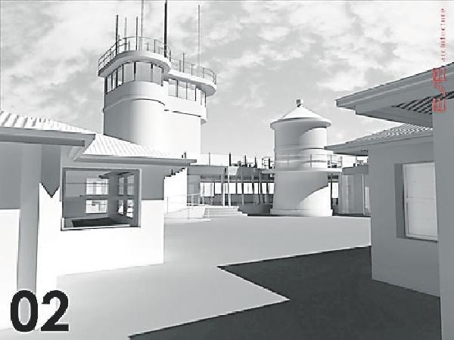
LANDMARK: Neil Slater's plan was for a restaurant under a viewing deck that hugged the lighthouse.
NOBBYS would become another Surf House if the various levels of government could not work together on heritage matters, Nobbys tourism proponent Neil Slater said yesterday.
Mr Slater was commenting after Federal Environment, Heritage and Arts Minister Peter Garrett sided with consultant heritage specialists, over the advice of his department, to refuse permission for the 50-seat restaurant and accommodation proposal.
A breakdown of submissions on the Slater plan provided by Mr Garrett's office yesterday showed that 270 favoured it, 184 opposed it and 23 expressed no clear view either way.
Mr Slater said Newcastle Port Corporation had been spending about $100,000 a year to maintain the headland and its approaches and he had been planning to spend as much, if not more, to keep the site in the condition required of a high-profile tourist destination.
He said governments or local councils were quite frequently the owners of heritage sites that fell vacant because they were "too old and too difficult to work with in the modern environment".
"So one arm of government walks away, invites the private sector to take over, but when this happens another arm of government comes in and says you can't do that, and makes it almost impossible for anyone to get anywhere," Mr Slater, who owns Scratchleys harbourside restaurant, said.
He named Nobbys, Merewether's Surf House, the former Newcastle Post Office and the heritage-related cost overruns on the Bellevue Hotel redevelopment in Newcastle West as examples of the private sector having a hard time satisfying the whim of governments.
He said he wanted to keep going with Nobbys but if Mr Garrett could not get the relevant government bodies, represented by "people with the ability to make decisions", together, there was probably little hope of progress.
Mr Garrett announced his decision on Monday and said a common theme of the more than 450 public submissions was "the desire of Newcastle people to have access to Nobbys".
"I support this sentiment but it is important in finding a way for the site to be more accessible that we do not do it in a way that damages the precious historical and heritage values of the lighthouse itself," Mr Garrett said.
Mr Slater said the report by heritage consultants Clive Lucas, Stapleton & Partners was full of inconsistencies.
"One criticism [of the proposal] is that its close proximity shows a lack of deference to the lighthouse'," Mr Slater said.
"What they don't say is that there is already an un-heritage double garage smack up against the lighthouse now, that will go under the proposal."

Contractors wait in the half-built wings

By IAN KIRKWOOD
May 16, 2008, 12:44 p.m.
- 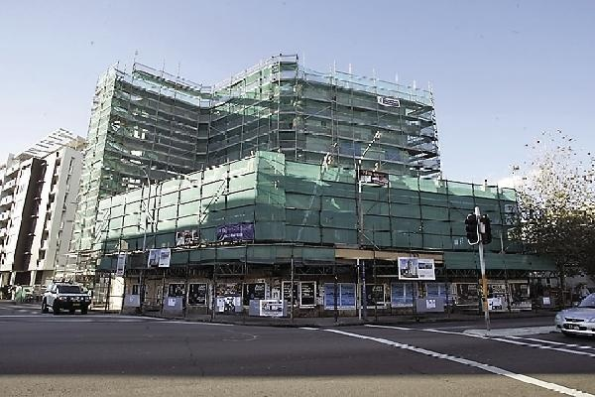
SHUT DOWN: The site of the development yesterday.
NOT AGAIN: PFM Plastering Specialists director Peter Majdandzic yesterday. Picture by Simone De Peak
THE already delayed Bellevue Hotel apartment block has been shut down while the developers seek new funding for the half-built project.
Subcontractors working on the eight-storey Task Developments site say they are owed an estimated $700,000 for the past three months of work and are concerned they will not be paid if the developers cannot refinance the project.
Architects Jackson Teece initially valued the project at $7 million, with the debt component of the funding to come from Port Macquarie company Momentum Mortgages.
Momentum spokesman Brad Gilbert confirmed his company would not be providing further financing for the job but declined to say why.
One contractor, PFM Plastering Specialists director Peter Majdandzic, said yesterday he was owed an estimated $300,000 after having about 20 plasterers working on the job.
"We had to go to court to get money owed for our work on the Menkens apartments, we did [lost] more than $140,000 in Bay Building, and now this," Mr Majdandzic said.
He said people in his situation had little choice but to "hope for the best".
Task Developments partner Scott McKenzie said the Bellevue job was shut on Wednesday and the consortium was looking for more funding.
A "tightening of funding requirements" and cost overruns because of heritage matters and other issues had caused delays, but he hoped to attract new finance and resume work on the site in the next few weeks.
He said 12 of 31 residential units had been pre-sold but Jackson Teece was no longer buying the old hotel section for its new offices.
A Jackson Teece spokesman said the deal fell over months ago. It was unrelated to a split at Jackson Teece that saw former partner Keith Savage, who remains a partner in Task Developments, leave the firm and move to Darwin.
The Bellevue job is one of a handful of projects under way in Newcastle West and a spokesman for the builders' union said all were needed for the precinct to go ahead.
"If one or two of these fall over, then it could be years before the West End recovers again," Construction, Forestry, Mining and Energy Union spokesman Peter Harris said yesterday.

1233 ABC Newcastle

Work stops on Bellevue Hotel redevelopment
Posted October 15, 2008 11:19:00

Map: Newcastle 2300
Work has come to a halt on the multi-million dollar Bellevue Hotel redevelopment in Newcastle's West End, after the collapse of the company funding the project.
Port Macquarie company Momentum Mortgages, who had been funding the eight-storey apartment complex, went into voluntary administration this week, bringing work to a standstill.
Momentum spokesman Brad Gilbert told the ABC on Monday the company appointed David Leigh, from insolvency firm PPB, while McGrath Nichols have been appointed receivers and managers.
Mr Leigh has called the first meeting of creditors next week but says he is unsure about future financial arrangements for the Bellevue redevelopment.
Work was shut down on the project several months ago when it ran into funding problems.
Plasterer Peter Majdandzic, like other subcontractors, says he has been locked out of the site and is uncertain if they will get any of the money they are owed.
"Momentum paid us the first debt that Task owed us when they took the job over but we've now lost in the vicinity of between $120, 000 and $130, 000," he said.
"It's a massive impact but we'll just go to the solicitor and see what he can do about it."
Tags: business-economics-and-finance, industry, building-and-construction, nsw, newcastle-2300, port-macquarie-2444

ABC Newcastle NSW All ABC Local
© 2013 ABC
Conditions of Use
Privacy Policy

